DIGITAL PAYMENTS & FRAUD ANALYTICS
ABSTRACT
The Digital Payments & Fraud Analytics project analyses digital payment transaction data to identify transaction patterns and fraudulent activities. The dataset contains 1,000 transaction records with information such as transaction amount, payment method, transaction type, location, device type, merchant category, customer age, transaction status, and fraud flag. The data is cleaned and prepared using Excel, analysed using SQL and Python, and visualized using Power BI. The dashboard provides important KPIs, fraud analysis, transaction trends, and interactive visualizations. The project helps identify fraud patterns and provides useful insights that can support better monitoring of digital payment transactions.

INTRODUCTION
Digital payment systems generate a large amount of transaction data every day. Analysing this data can help organizations understand transaction behaviour and identify potentially fraudulent activities. Fraudulent transactions can lead to financial losses and affect customer trust. Therefore, effective analysis of payment data is important for monitoring transaction patterns and identifying unusual activities.
In this project, digital payment transaction data is analysed using Excel, SQL, and Python and visualized using Power BI. The main purpose is to analyse transaction behaviour, understand fraud patterns, calculate important KPIs, and present meaningful insights through an interactive dashboard.

PROBLEM STATEMENT
Digital payment transactions are increasing rapidly, making fraud detection an important business requirement. Large numbers of transactions make it difficult to manually identify suspicious activities and understand fraud patterns.
This project analyzes digital payment transaction data to identify fraudulent transactions, understand transaction patterns, measure fraud rates, and provide useful business insights through data analysis and visualization.
The analysis helps businesses understand where, when, and through which transaction characteristics fraud is occurring, so that they can improve fraud monitoring and decision-making.

PROJECT OBJECTIVE
The main objectives of this project are:
To clean and prepare digital payment transaction data.
To analyze transaction data using Excel.
To store and analyze the cleaned data using MySQL and SQL.
To perform Exploratory Data Analysis (EDA) using Python.
To identify important fraud patterns and transaction trends.
To calculate important fraud-related KPIs.
To create an interactive Power BI report and dashboard.
To generate business insights from the analyzed data.
To support better fraud monitoring and business decision-making.

DATASET DESCRIPTION
The dataset contains 1,000 digital payment transactions.
The dataset includes information such as:
Transaction ID
Transaction Date
Transaction Time
Customer ID
Amount
Payment Method
Transaction Type
Location
Device Type
Merchant Category
Customer Age
Transaction Status
Fraud Flag
Additional derived fields were created during the analysis, such as:
Transaction Hour
Time Period
Amount Category
The dataset was prepared and cleaned before performing further analysis.

DATA CLEANING - MS EXCEL
The raw transaction data was first processed using MS Excel.
The main data-cleaning activities included:
Checking the dataset for missing values.
Identifying and handling blank values.
Checking for duplicate transactions.
Reviewing data types and formats.
Standardizing date and time information.
Checking transaction amounts for consistency.
Reviewing categorical fields such as Payment Method, Location, Device Type, and Merchant Category.
Preparing the cleaned dataset for SQL, Python, and Power BI analysis.
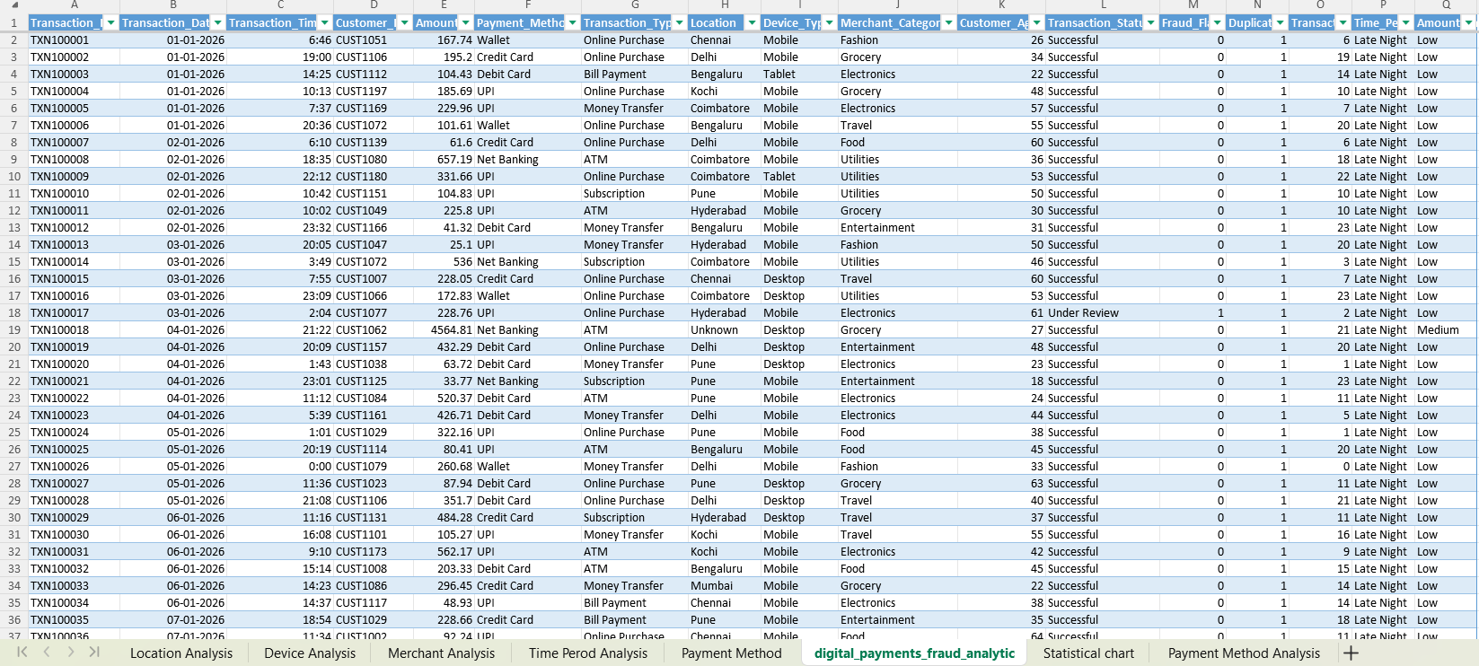
Figure 1: Data Cleaning and Preparation using MS Excel
After cleaning, the prepared dataset was saved in both Excel and CSV formats for further analysis.

SQL ANALYSIS - MYSQL
The cleaned dataset was imported into MySQL for database-based analysis.
A database named:
digital_payments
was created, and the transaction data was stored in the transactions table.
SQL was used to analyze the transaction data and calculate important business metrics.
The analysis included:
Total number of transactions.
Total transaction value.
Average transaction value.
Fraudulent transaction count.
Fraud amount.
Fraud rate.
Transaction analysis by payment method.
Transaction analysis by location.
Transaction analysis by device type.
Transaction analysis by merchant category.
Transaction analysis by transaction type.
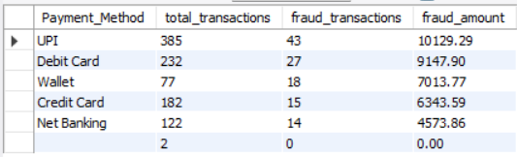
Figure 2: SQL Analysis and Query Results using MySQL
SQL helped organize and analyze the transaction data efficiently using queries.

PYTHON ANALYSIS - EDA
Python was used to perform Exploratory Data Analysis (EDA) on the cleaned transaction dataset.
The main Python libraries used were:
Pandas
NumPy
Matplotlib
Seaborn
The analysis included:
Loading the cleaned dataset.
Checking the dataset structure and dimensions.
Examining data types.
Checking transaction and fraud distributions.
Analyzing numerical and categorical variables.
Exploring fraud patterns across different transaction characteristics.
Creating charts to understand the data visually.
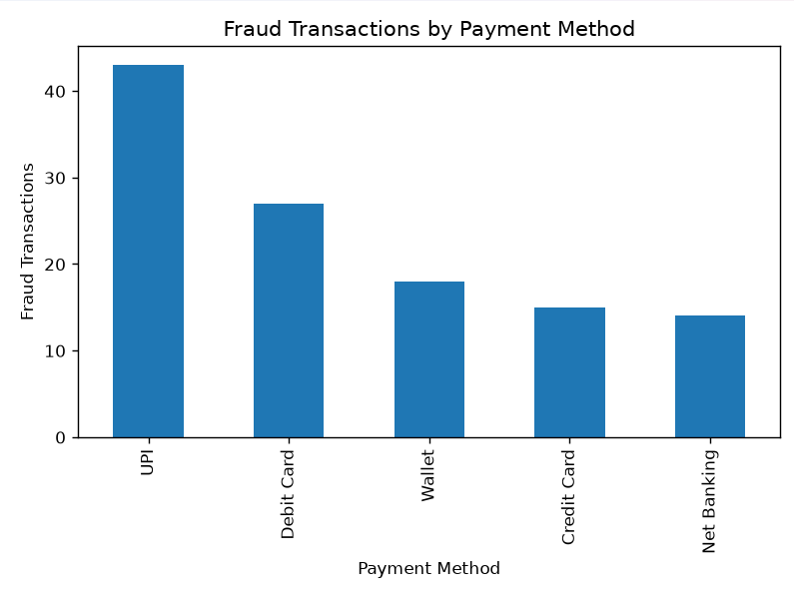
Figure 3: Exploratory Data Analysis using Python
Python EDA helped identify patterns and relationships in the dataset before creating the final Power BI visualizations.
POWER BI REPORT & DASHBOARD
Power BI was used to create an interactive report for monitoring digital payment transactions and fraud patterns.
The Power BI report contains:
KPI Cards
Fraud analysis charts
Transaction analysis
Slicers/filters
Transaction-level details
The Executive Overview page provides a high-level summary of the project using important KPI cards.
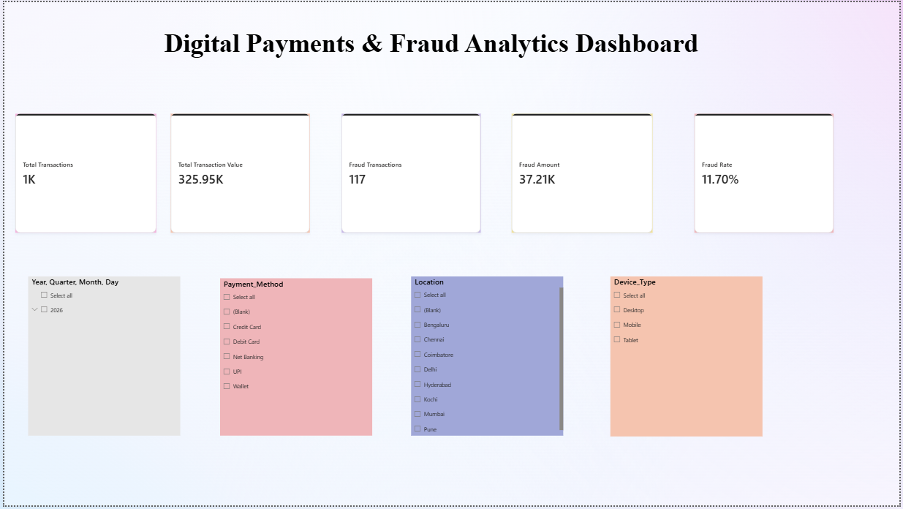
Figure 4.1: Digital Payments & Fraud Analytics - Executive Overview Dashboard
The dashboard analyzes transaction and fraud patterns across:
Payment Method
Location
Device Type
Merchant Category
Transaction Type
Time Period
Amount Category
Interactive slicers allow users to filter the data and explore different transaction segments.

KPIs
The following important KPIs were created in Power BI using DAX measures:
Figure 4.2: Key Performance Indicators (KPIs) in Power BI

Total Transactions
1,000
This represents the total number of transactions analyzed.

Total Transaction Value
₹325,947.29
This represents the total monetary value of all analyzed transactions.

Fraud Transactions
117
This represents the number of transactions identified as fraudulent.

Fraud Amount
₹37,208.41
This represents the total transaction amount associated with fraudulent transactions.

Fraud Rate
11.70%
This represents the percentage of transactions identified as fraudulent.
These KPIs provide a quick overview of the overall transaction and fraud situation.

BUSINESS INSIGHTS

Transaction Overview
A total of 1,000 digital payment transactions were analyzed.

Fraud Overview
117 transactions were identified as fraudulent, resulting in an overall fraud rate of 11.70%.

Transaction Value
The total transaction value analyzed was approximately ₹325,947.29.

Fraud Amount
The total value associated with fraudulent transactions was approximately ₹37,208.41.

Fraud Pattern Analysis
Fraudulent transactions were analyzed across different dimensions, including payment methods, locations, device types, merchant categories, transaction types, time periods, and transaction amount categories.
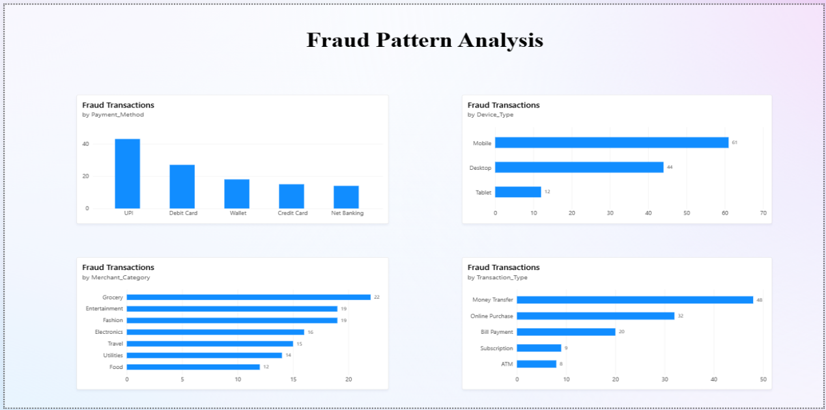
Figure 4.3: Fraud Pattern Analysis using Power BI
The Power BI dashboard makes it easier to compare these dimensions and identify areas that may require closer monitoring.

BUSINESS RECOMMENDATION
Payment platforms can use these analytical patterns to monitor potentially high-risk transaction segments, investigate unusual transactions, and strengthen fraud-monitoring controls.
CONCLUSION
The Digital Payments & Fraud Analytics project demonstrates how data can be transformed into useful business insights through a complete data analytics workflow. The project used Excel for data cleaning and initial data preparation, MySQL and SQL for database analysis, Python for Exploratory Data Analysis, and Power BI for interactive visualization and reporting. The analysis identified 1,000 total transactions, 117 fraudulent transactions, a fraud rate of 11.70%, a total transaction value of ₹325,947.29, and a fraud amount of ₹37,208.41. The final Power BI dashboard provides an interactive way to monitor key fraud metrics and analyze fraud patterns across multiple transaction dimensions. Overall, the project demonstrates the practical use of Excel, SQL, Python, and Power BI in solving a real-world data analytics and fraud monitoring problem.

REFERENCES
Microsoft Power BI Documentation
MySQL Documentation
Python Pandas Documentation
Microsoft Excel Documentation

